Healthcare Catering Chef’s Competition at

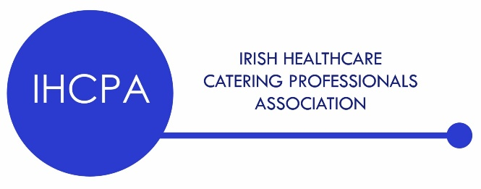Chef Ireland 2025

**Open to all Chef's working in Healthcare and Hospital Catering**

A Team of two chefs will be allowed 60 minutes to prepare, cook and present 6 plated portions of a hot chicken dish.

Three (3) identical, individual plates of a chicken dish, suitable for renal diet.

and,

Three (3) identical, individual plates of an IDDSI level 4 chicken dish, suitable for dysphagia diet.

Both dishes to be photographed and submitted with recipe, ingredients, method, allergens and calorie count by 1st of January 2025 for judge’s final selection. Please email these details, including your completed entry form to [chefireland13@hotmail.com](mailto:chefireland13@hotmail.com) and transfer the entry fee of €25.00 by Revolute to @brendab4et

Dishes should be nutritionally balanced with protein, carbohydrates, vegetables and sauce. Awareness of sodium, potassium, phosphates and sulphites must be evident. Recycling and food waste regulations must be adhered to.

Basic sauces and washing and peeling of vegetables is the **only** mis en place allowed.

All equipment required to complete the dishes must be provided by the competitor.

The kitchen plan, heavy cooking equipment and available refrigeration are listed under the general competition rules in the competition brochure.